List of Puzzles

# Belo Horizonte

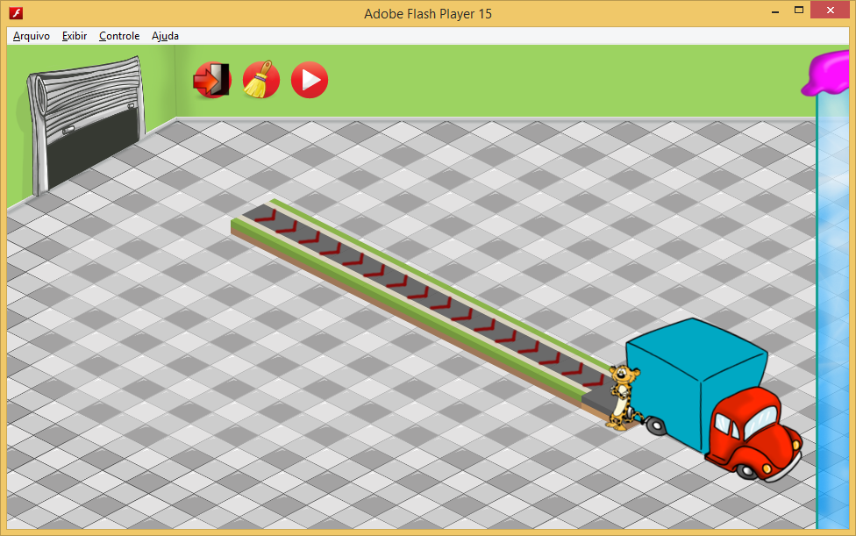

Difficulty of Puzzles: EASY

Puzzle 1

|  |  |  |
| --- | --- | --- |
| Request: |  | 1x |

Possible solution:

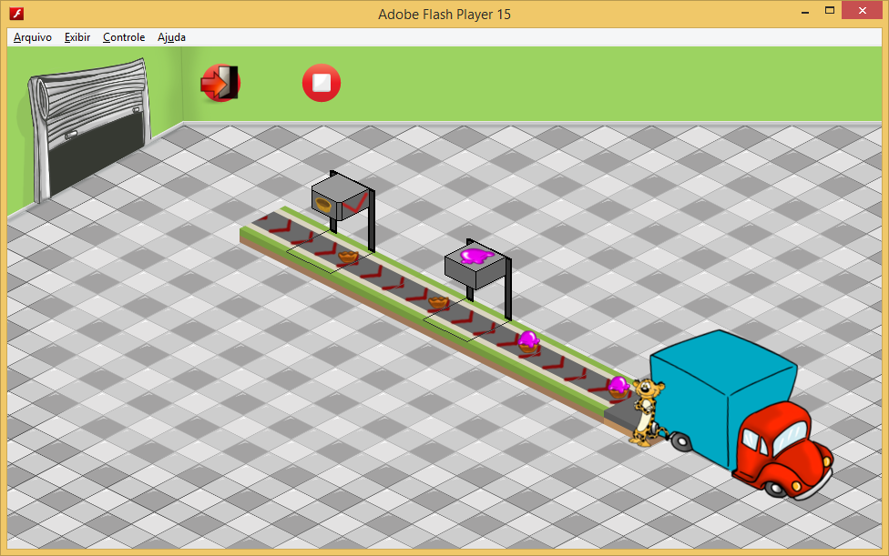

Puzzle 2

|  |  |  |
| --- | --- | --- |
| Request: |  | 1x |

Possible solution:

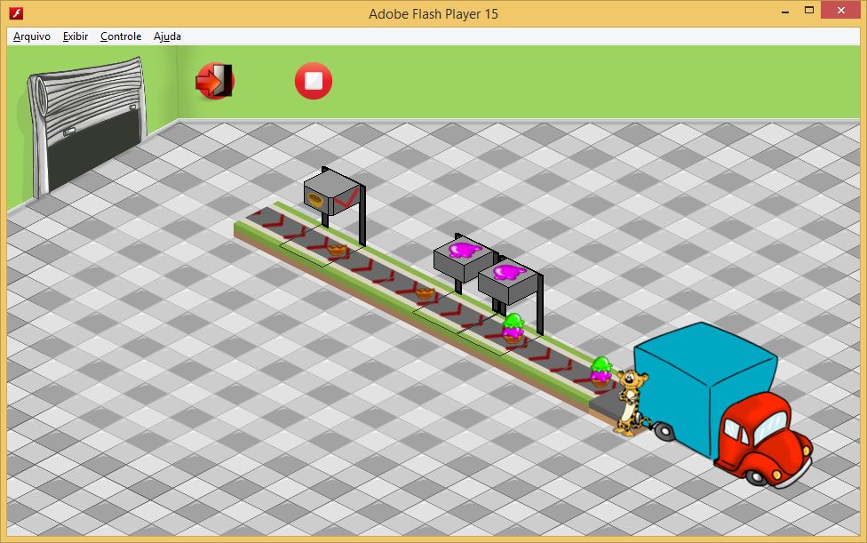

Puzzle 3

|  |  |  |  |  |
| --- | --- | --- | --- | --- |
| Request: |  | 1x |  | 1x |

Possible solution:

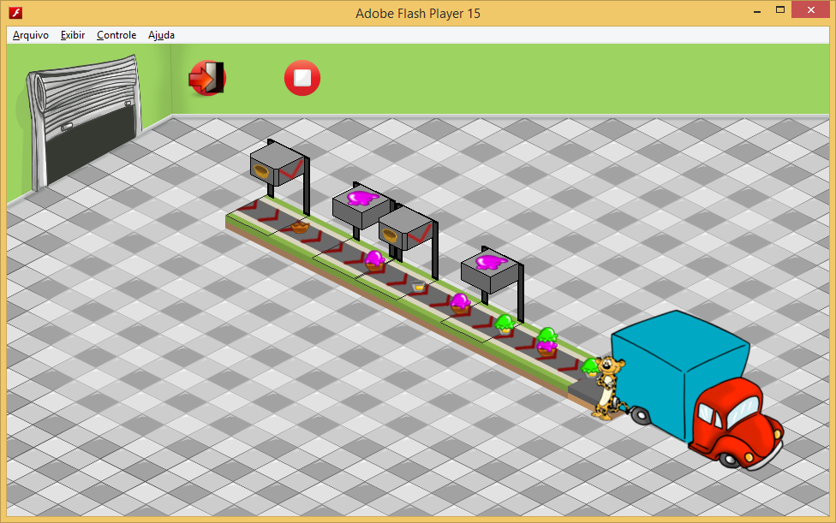

Puzzle 4

|  |  |  |  |  |
| --- | --- | --- | --- | --- |
| Request: |  | 1x |  | 1x |

Possible solution:

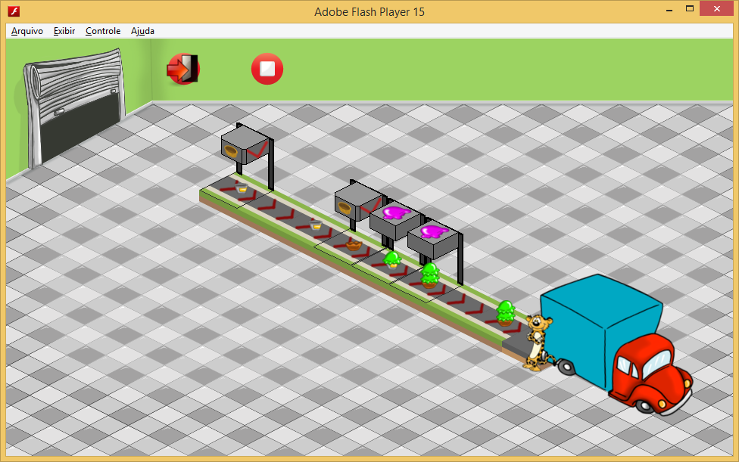

# Cuiabá

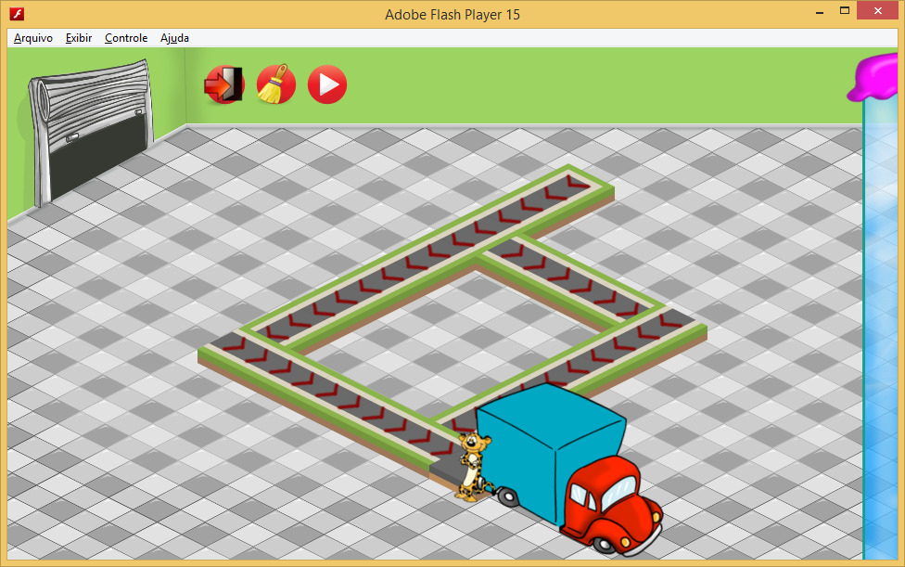

Difficulty of Puzzles: EASY/MEDIUM

Puzzle 1

|  |  |  |  |  |
| --- | --- | --- | --- | --- |
| Request: |  | 1x |  | 1x |

Possible solution:

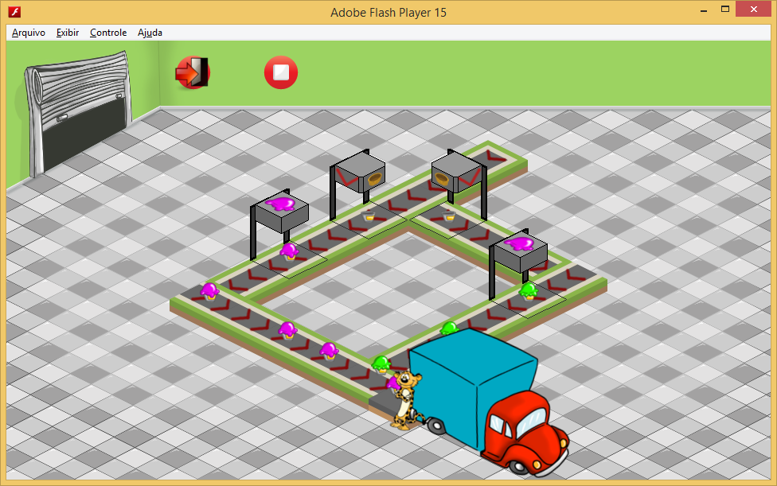

Puzzle 2

|  |  |  |  |  |
| --- | --- | --- | --- | --- |
| Request: |  | 1x |  | 1x |

Possible solution:

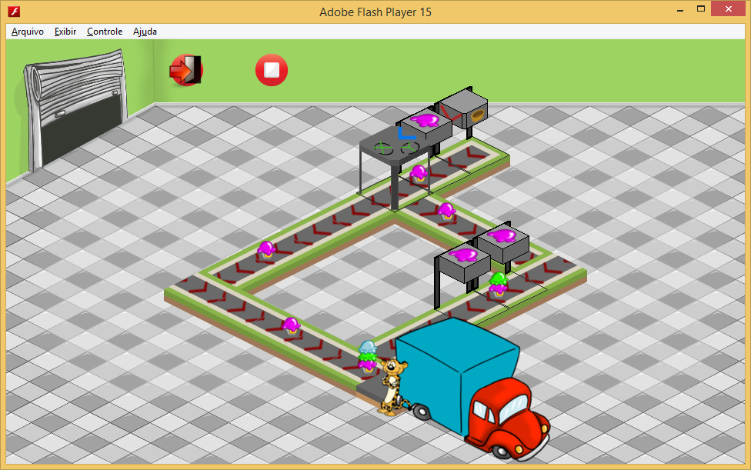

Puzzle 3

|  |  |  |  |
| --- | --- | --- | --- |
| Request: | 1x | 1x | 2x |

Possible solution:

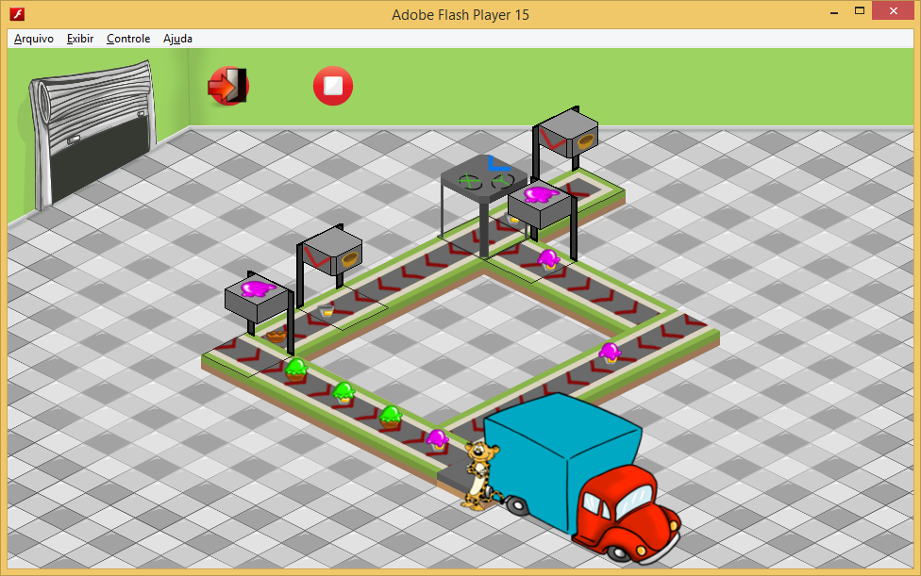

Puzzle 4

|  |  |  |  |  |
| --- | --- | --- | --- | --- |
| Request: |  | 1x |  | 1x |

Possible solution:

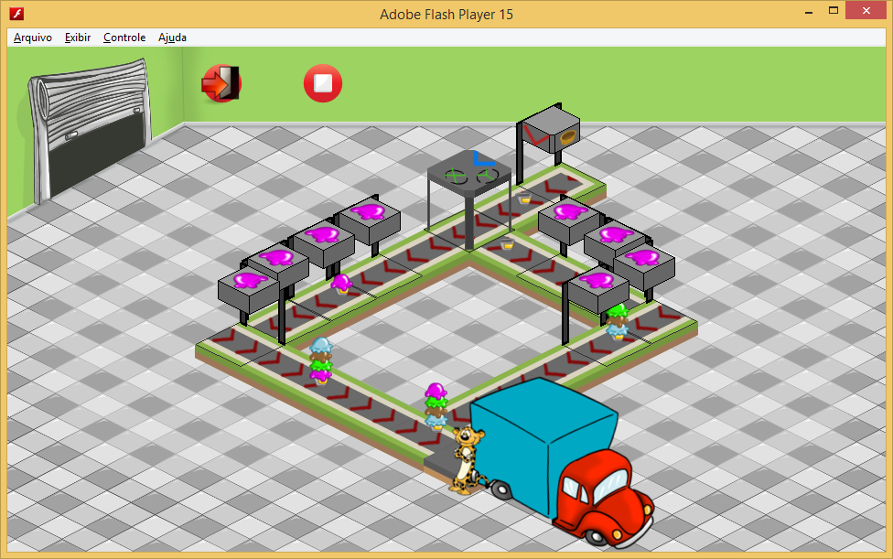

# Manaus

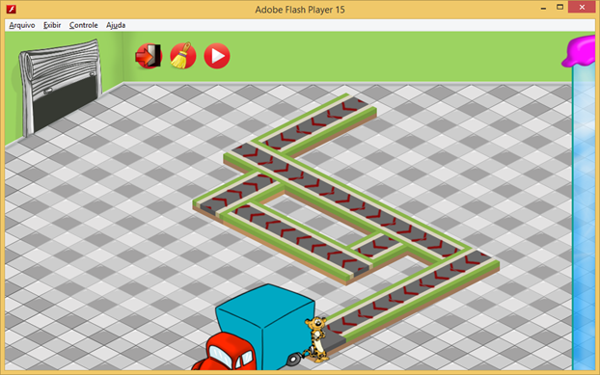

Difficulty of Puzzles: MEDIUM

Puzzle 1

|  |  |  |  |  |
| --- | --- | --- | --- | --- |
| Request: |  | 1x |  |  |

Possible solution:

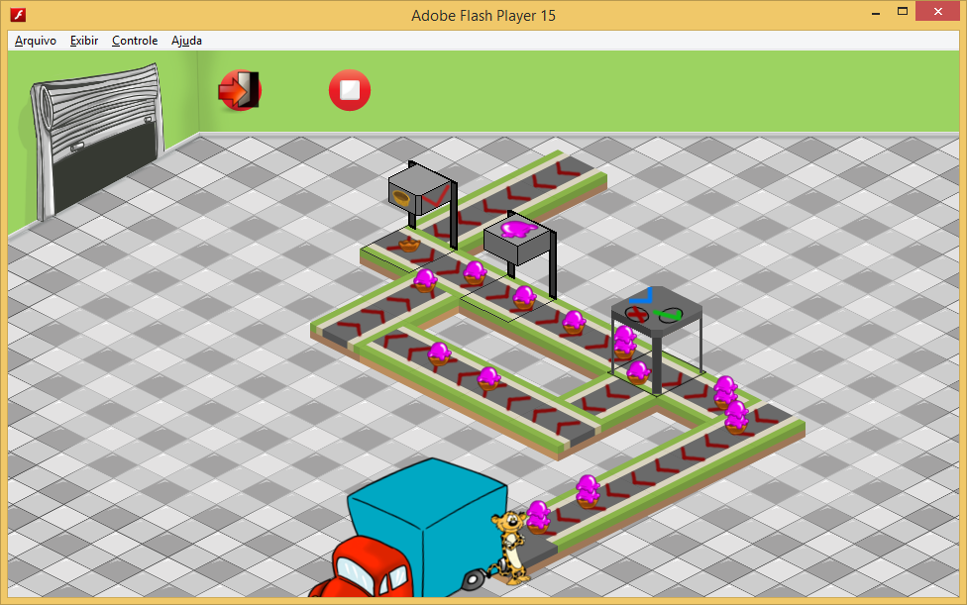

Puzzle 2

|  |  |  |  |  |
| --- | --- | --- | --- | --- |
| Request: |  | 1x |  | 1x |

Possible solution:

Puzzle 3

|  |  |  |  |
| --- | --- | --- | --- |
| Request: | 1x |  |  |

Possible solution:

Puzzle 4

|  |  |  |  |  |
| --- | --- | --- | --- | --- |
| Request: |  | 1x |  | 1x |

Possible solution: